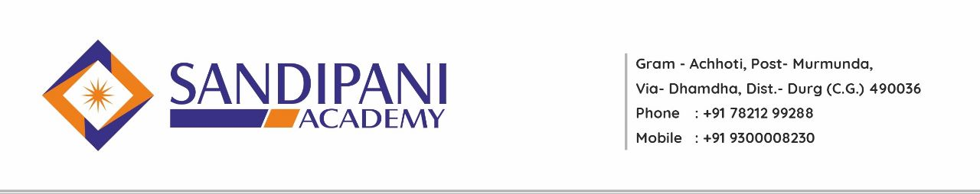
Program: B.A. B.Ed.
Program Learning Outcome
B.A. B.Ed. (Integrated Bachelor of Arts - Bachelor of Education) is a teacher training program. Candidates, who complete this course, are qualified to teach at secondary and senior secondary schools in the Indian schooling system and to acquire a job, they should pass relevant aptitude tests. B.A B.Ed. the course has been created remembering the requirements of 12th pass students. B.Ed., in its independent form, can be pursued only after completing graduation.
- A student can pursue a single teacher training course directly after class 12th or can apply separately for a teacher training course after graduation.

- The course comprises of B.A. program just as B.Ed. program. Both the courses are joined to frame an integrated course. Hence, students won’t have to apply independently for B.Ed.

- The integrated B.A. B.Ed course continues for a time of 4 years only. The incorporated program is a double degree in nature. Toward the completion of the course, graduates will be granted two degrees – A bachelor’s degree (selected by the student) and B.Ed. degree. Obtaining 2 degrees within 4 years is an excellent arrangement.

- Along with the advantage of saving 1 year, it will assist one with saving money likewise as the fee of each college increases each year and if one takes admission in B.Ed. after 3 years then the expense for the same will be moderately high then the expense of B.Ed. integrated.

After the completion of this program student teachers will be able to:
- Students will opt teaching as profession.
- They will become social researcher and social scientist.
- They will pursue higher education like M.A. M.Ed and Ph.d. in Education.
- They will seek job opportunities in Higher Eduction as NCERT, NCTE etc.
- They will become counselor and mentors. Recall and recognize some educational terminology, educationists, psychologists, some basic concepts, definitions of Education, Learning, and Teaching etc. Understand basic concepts and ideas of educational theory.
- Comprehend the role of the systems of governance and structural – functional provisions that support school education.
- Develop understanding about teaching, pedagogy, school management and community involvement. Build skills and abilities of communication, reflection, art, aesthetics, theatre, self-expression and ICT.
- Applies the knowledge in the course of teaching in the schools.
- Applies various methods, strategies and approaches while teaching a lesson.
- Uses the techniques learnt during the programme in the profession.
- Synthesize new methods, strategies, theories on the basis of the knowledge gained during the progamme.
- Appreciates the contributions of philosophers, educationists and sociologists for the development of educational theory and practice.
- Uses the ICT widely in all spheres of educational theory and practice
- Appreciates the role of ICT in making the educational more reachable, making the concepts easy, catering to the needs of the individual learning at their own pace.
- Develops the skill in both micro-teaching and macro teaching.

